Homework IV, ES207

Amir Sharafi

02/18/2020

* Small Description of my entire project?

This research is aimed to design and develop the new zero-emissions electricity generation system with using the piezoelectric material. Unlike the renewable energy, the source for this system comes from existing human activities without any increase in the amount of energy consumption or greenhouse gas emissions of those activities. The second section of the study is intended to evaluate the environmental impact of the system and determine the total emission of the system from the cradle to the grave. Then find the best possible location for installing this device in the whole of California.

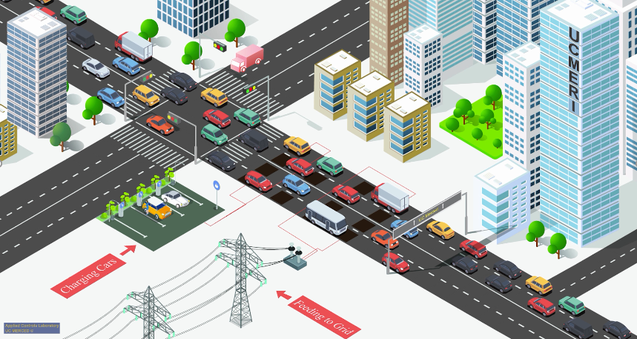

* What is your research question?

For the last part of this project, Since the capacity factor of this system highly depends on the number of passing vehicles. The best locations, including highways, roads, and cities' streets, for installations of the piezoelectric energy harvesting system will be determined by utilizing the Geographic information system (GIS).

* What is your scientific hypothesis?

Find feasible roads or highways in California for installing the generator under them which economically beneficial and have minimal impacts on the environment.

* Describe the anticipated data including:

1. Nominal Data: average speed of the car, weights of the vehicle, number of cars per day, number of the lanes in the road, length of the system, distance to the grid,
2. Categorical Data: Holiday or weekday, season, type of car, type of system: feeding the gird or storage system
3. Distribution: Location (Road, highways, and street in California), Time (time in day, …)

* What is your anticipated analysis?

I believe we should find the interval of the number of cars per lane per time

* What is your statistical hypothesis?

First one will be: What is the number of passing cars per lane per day that the LCA result will be 50 kg CO2/ kWh

* What is the NULL?

With passing 10 000 cars /lane /day, LCA result is almost 50 kg CO2/ kWh

* What is the alternative hypotheses?

With passing 10 000 cars /lane /day, LCA result is almost 75 kg CO2/ kWh

(the problem is time distribution of passing car per day)